Operating Systems Project – PHASE 2 Report
Phase 2 — Servers Configuration
Server setup and configuration tasks will be completed in Phase
- Server to configure:
- DHCP Server

INTRODUCTION
Dynamic Host Configuration Protocol (DHCP) is a network management protocol used to automatically assign IP addresses and other network configuration parameters to devices on a network. DHCP eliminates the need for manual IP configuration and ensures efficient IP address management.

IMPLEMENTATION
Role Assignment
Ubuntu 1 → DHCP Server
Ubuntu 2 → DHCP Client

Network Interface → ens33
Network Range → 192.168.25.100 – 192.168.25.200
Subnet Mask → 255.255.255.0
Gateway → 192.168.25.1
DNS Server → 192.168.25.131

Step 1 – Install DHCP Server (Ubuntu-1)
sudo apt update
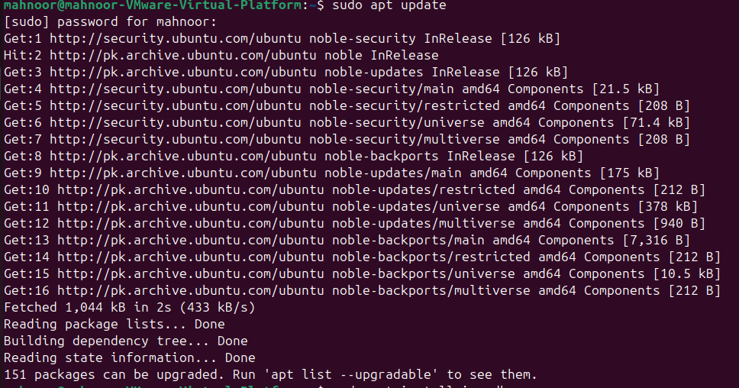
sudo apt install isc-dhcp-server -y
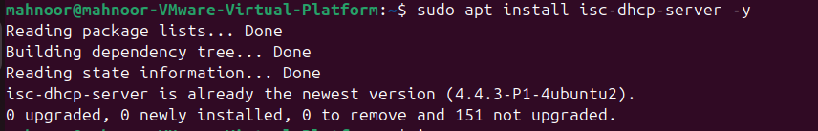
Step 2 – Configure DHCP Interface (Ubuntu-1)

sudo nano /etc/default/isc-dhcp-server
Set:
INTERFACESv4="ens33"

Step 3 – Configure DHCP Server Settings (Ubuntu-1)

sudo nano /etc/dhcp/dhcpd.conf
Add configuration:

authoritative;

default-lease-time 600;
max-lease-time 7200;

subnet 192.168.108.0 netmask 255.255.255.0 {
range 192.168.108.150 192.168.108.200;
option routers 192.168.108.1;
option domain-name-servers 8.8.8.8, 8.8.4.4;
}
Step 4 – Restart DHCP Service

sudo systemctl restart isc-dhcp-server
sudo systemctl status isc-dhcp-server

Service showing active (running)
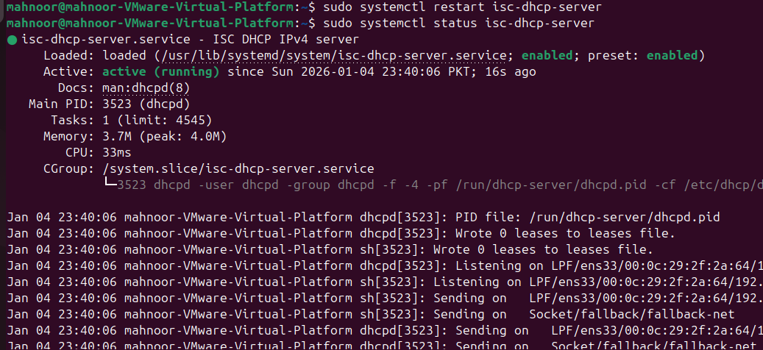
Step 5 – Configure DHCP Client (Ubuntu-2)

sudo nano /etc/netplan/00-installer-config-yaml
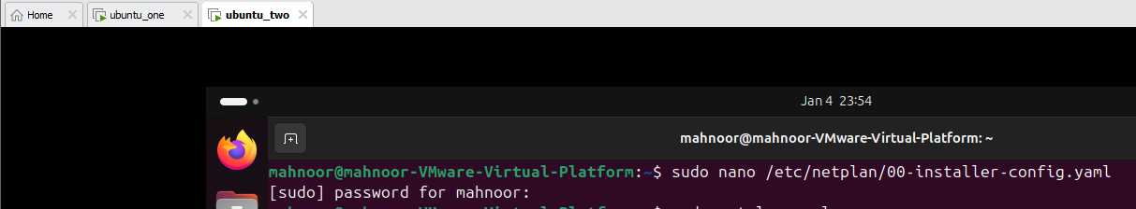
sudo netplan apply
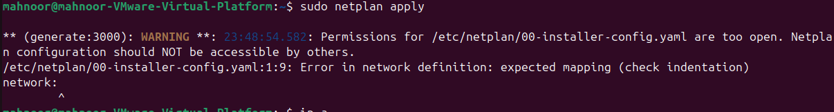
Step 6 – Verify IP Assignment (Ubuntu-2)

ip a
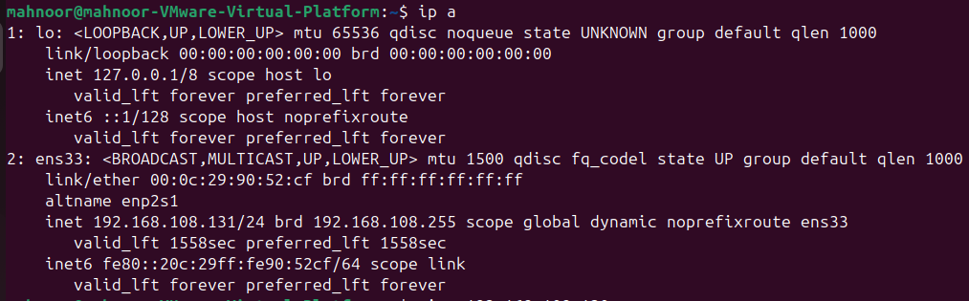
Pinging
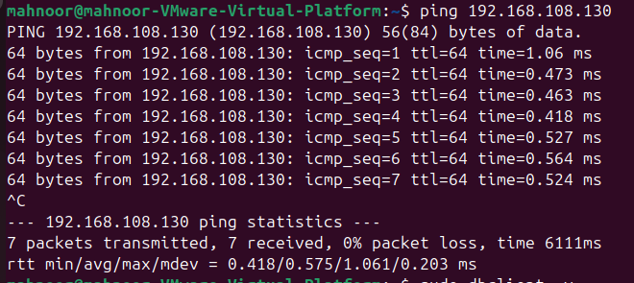
Expected:
Client receives IP address automatically from DHCP server.
Ubuntu 1: (check)
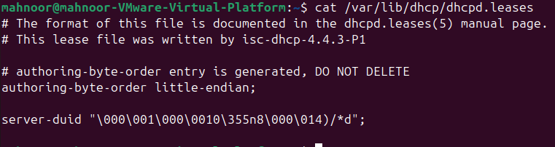

CONCLUSION
The DHCP server was successfully configured on Ubuntu using isc-dhcp-server. The client system automatically received IP address and network configuration parameters, confirming correct DHCP functionality within the network.

_____________________________________________________

